VEST

# Objective:

The Smith & Nephew’s VEST developed using VBA customizations need to be converted to .NET framework in compatible with AutoCAD 2018, adhering to best practices, supporting 64 bit architectures.

# Overview:

VEST has 3 functions “Vest”, “Arm” and “Torso” to draw Vest Body details, Arm details and Torso details in AutoCAD.

This document gives an outline of input details need to generate required output, working flow and output details of VEST module in Smith & Nephew project.

# Description:

# Scope:

* VEST module is used to draw Vest Body, ARM and Torso in the standard template drawing “SN.dwt” using the details from “MAINPATIENTDETAILS” block reference.
* For VEST module, first we need to update the attributes of “MAINPATIENTDETAILS” block reference using NEWPATIENT command. Without that, we can’t run VEST module.

# Technology:

We are using VB.net technology and AutoCAD 2018 for VEST.

# Deliverable:

AutoCAD 2018 customized plug-in DLL.

# Steps to Run:

1. Open AutoCAD 2018 and open a drawing using “SN.dwt” template file.
2. Run NETLOAD command in Command prompt.
3. Load the updated “SmithNephew.dll” file in AutoCAD.
4. Run NEWPATIENT command in Command Prompt and update the attribute values in “MAINPATIENTDETAILS” block reference.
5. Run VEST command in Command Prompt.
6. “Vest” dialog will be opened.
7. In that dialog, we have 3 tabs (Vest, Arm and Torso).
8. Enter the required details for required Part (Vest Body or Arm or Torso).
9. After entering details, click draw button.
10. Now, the required Vest Body or Arm or Torso will be drawn successfully in AutoCAD.

# Dialog Design:

# Vest:

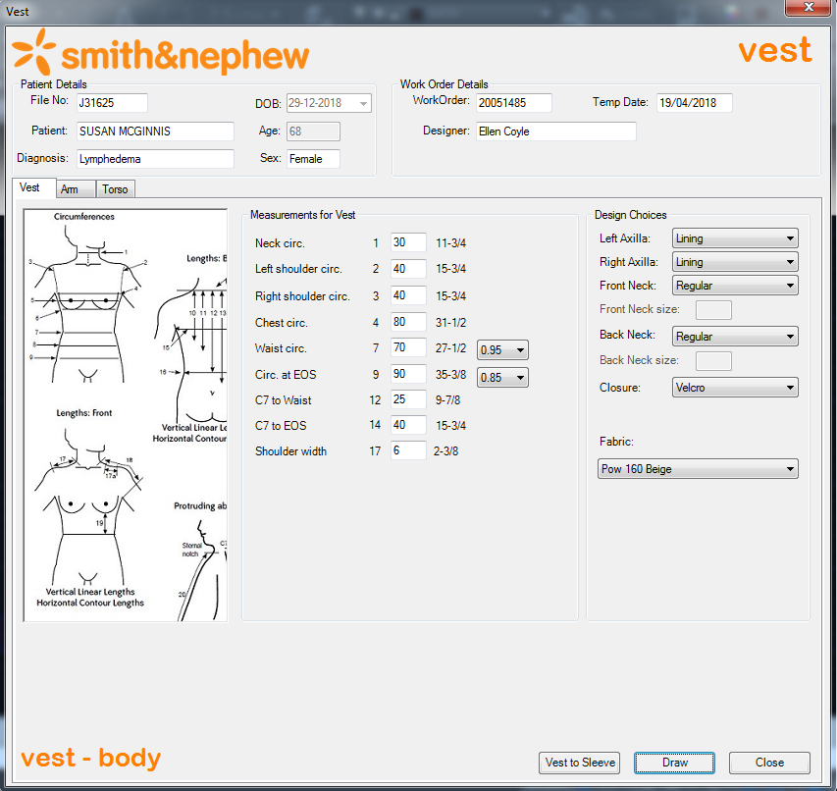

# Arm – Left Arm:

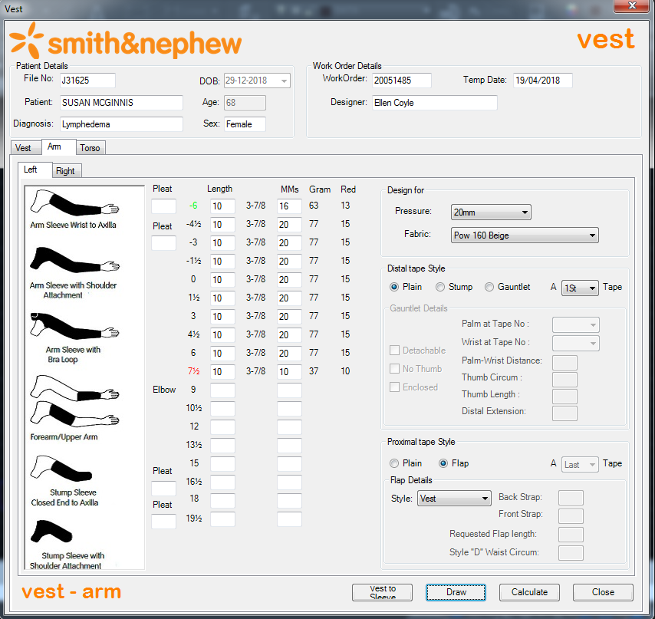

# Arm – Right Arm:

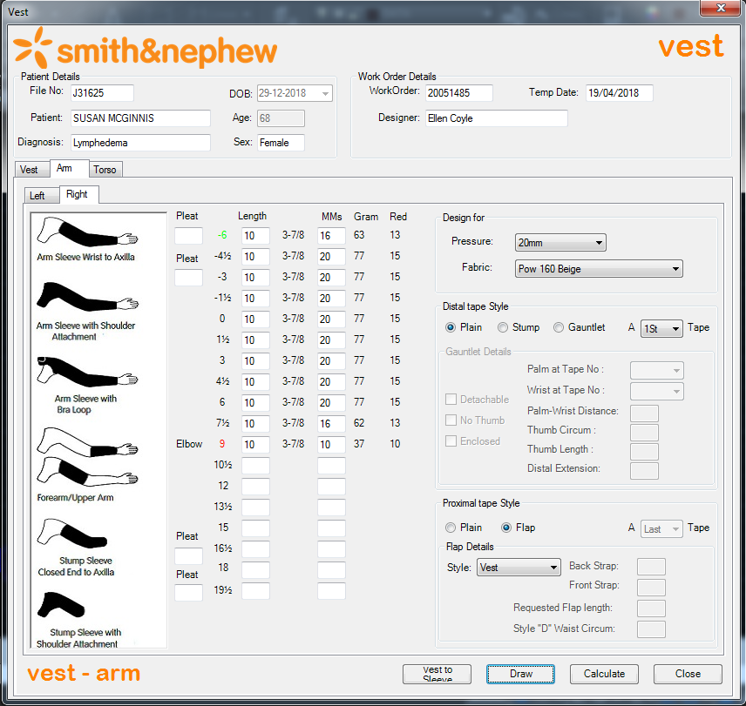

# Note:

To draw Left and Right Arm, first we need to draw Vest Body. Because the “Vest” Flap style in Left and Right Arm will read some attribute values of Vest Body block reference.

# Torso:

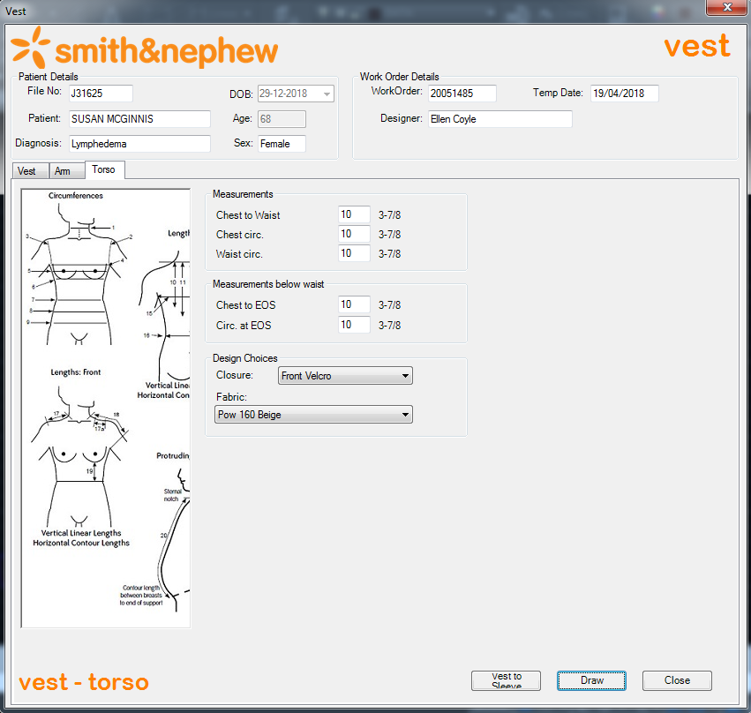

# Required Output:

# Vest:

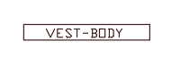

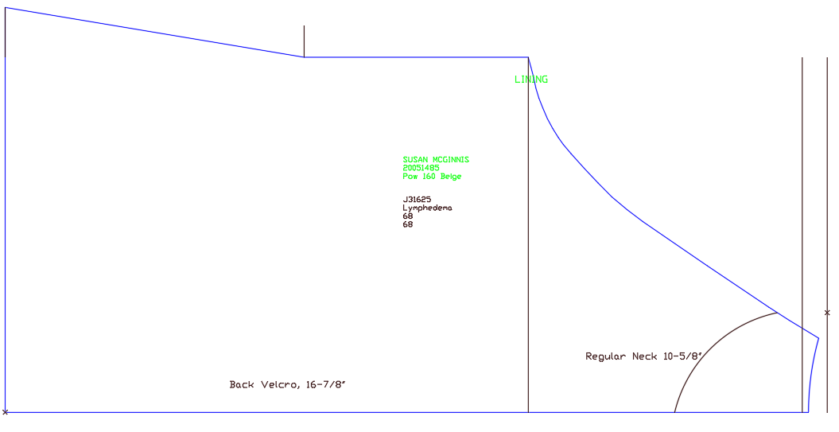

# Arm – Left Arm:

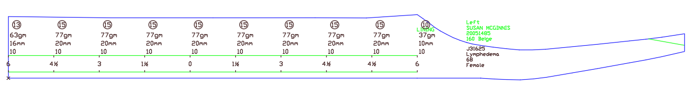

# Arm – Right Arm:

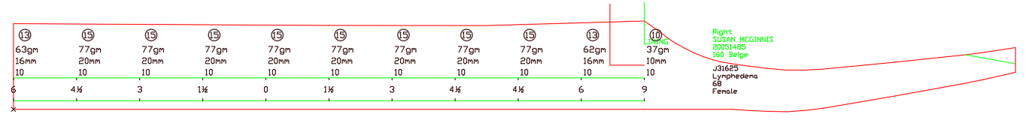

# Torso:

